**OKTA and OAuth – Authentication and Authorization server.**

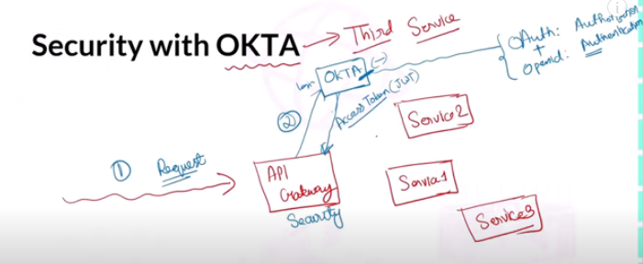

Mobile Client 🡪 API Gateway 🡪 OKTA and OKTA return JSON Access Token (JWT) 🡪 then access the services.

**Okta is OpenID Certified**

**OpenID provider:** The authorization server that issues the ID token. In this case Okta is the OpenID provider.

First time user provides credentials for authentication and get access token and users get authorized to send/receive HTTP request.

Second time use provide user try to access the service that time provide Token in header only not need to provide credentials.

**Spring Cloud Gateway WebFlux Security:**

Spring Cloud Gateway requires the Netty runtime provided by Spring Boot and Spring Webflux.

@EnableWebSecurity *// Normal servlet container used. Applied in services*

@EnableWebFluxSecurity *// Not Normal servlet container used. Applied in API Gateway level.*

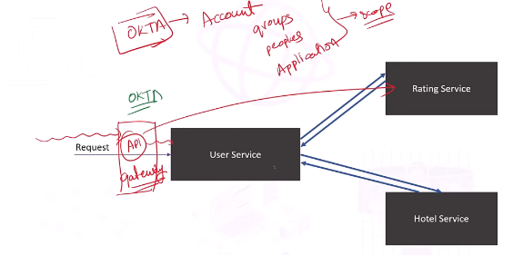

Feign Client Interceptor:

Why Interceptor required –

When Feign Client sending request , security will stopped and again enable to send request with header request.

In userServiceImpl

Hotel hotel = hotelService.getHotel(rating.getHotelId()); *//Calling by FeignClient*

Rest Template Interceptor:

Why Interceptor required –